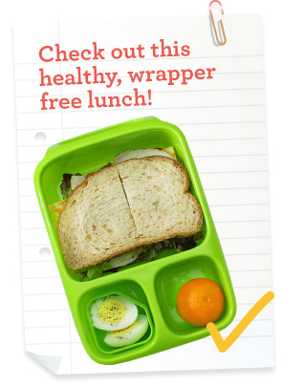
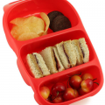
`

EcoWarriors

NUDE FOOD Colouring Competition
For Years Kinder – Year2

Nude food means food that is not packaged or wrapped in plastic, alfoil or sandwich bags.
The aim of the competition is to minimise rubbish and the use of plastic in our school.

There will be 1st 2nd and 3rd prizes awarded for each class

The competition will end Friday week 10
Prizes will be awarded Week 11

The Evans River K-12 School EcoWarriors promote waste free lunches. Waste-free lunches are not only a wise environmental choice; they are less expensive as well.

